BRAC UNIVERSITY
Department of Computer Science and Engineering

Examination: Semester Final  Duration: 1 Hour 45 min | Semester: Summer 2022  Full Marks: 40
CSE 320: Data Communications

Answer the following questions.
Figures in the right margin indicate marks.

SET B

Name: | ID: | Section:

1. CO2 | a) | Show the staircase in the following graph and generate the digital data from the given analog signal using the Delta Modulation (DM) technique.  Answer this question in the question paper itself. You don’t have to answer this question in the answer script. 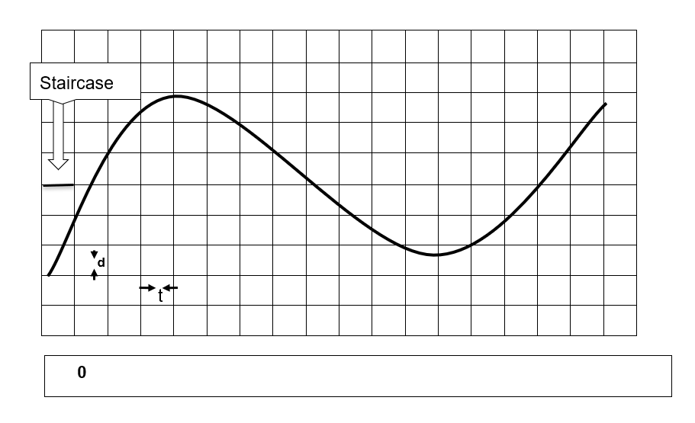 | 6
CO4 | b) | Suppose you want to hold an online gaming tournament final between two teams. Each team contains 5 players and each player will use a single PC. But the issue is that the two teams will participate from 2 different gaming zones which belong to 2 different networks. All the members of the same team belong to the same network. So, the situation is given below:  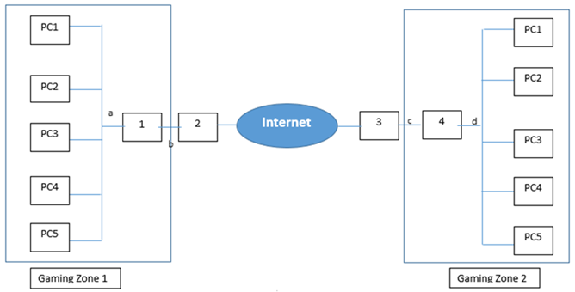  Now that you are given the design of the whole network, do the following to complete the network design: -  I. Identify the interconnecting device to be used in boxes marked 1, 2, 3, 4.  II. Identify the types of cables (Straight-through/copper crossover) to be used in places marked a, b, c, d. | 4
2. CO3 | a) | Consider there are five channels, two with a bit rate of 240 kbps and three with a bit rate of 180 kbps, are to be multiplexed using multiple-slot TDM with one synchronization bit. Write the following answers:  I. What is the size of a frame in bits?  II. What is the frame rate?  III. What is the duration of a frame?  IV. What is the data rate?  V. What is the output bit duration?  VI. How many input channels are there after doing multiple-slot TDM? | 6
 | b) | Why is the guard band necessary to use in FDM and not in TDM? Assume twelve 5.2 kHz channels are multiplexed in a 69 kHz channel using FDM. Calculate the bandwidth of the guard bands. Illustrate with visual representation. | 4
3. CO3 | a) | How does DSSS achieve bandwidth spreading and provides privacy? Sketch the Spread Signal from the following Original Signal and the given spreading code.  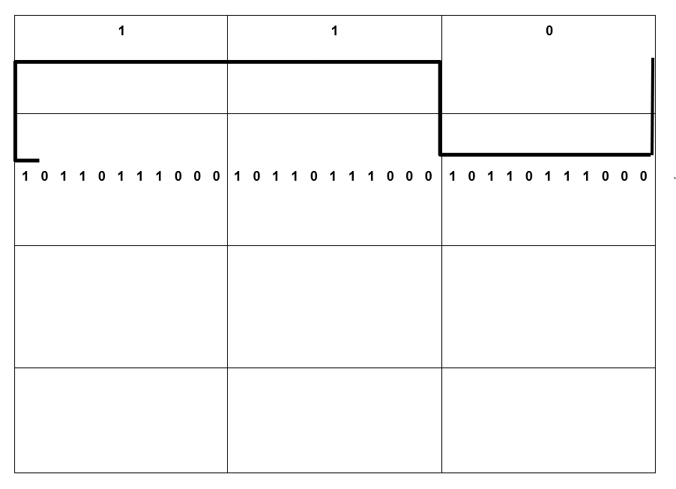 | 6
CO5 | b) | In Slotted Aloha when the number of nodes increases, the efficiency decreases, Explain how? | 4
4. CO5 | a) | Suppose you want to transmit the message 11011011 and protect it from errors using the CRC generator polynomial x³ + 1. Using binary division, show the message that should be transmitted.  Later, corrupt the left-most third bit of the transmitted message and show that the error is detected by the receiver using CRC technique. | 6
 | b) | Classify the medium access protocols which are collision-free. Why the efficiency of pure ALOHA is half of slotted ALOHA technique? | 4

---END---

